Project Report
Sentiment Analysis of X (Twitter) Posts Using VADER Sentiment Analyzer
Introduction
Social media has become an essential platform for communication and information sharing. Millions of users post their opinions daily on various topics, creating a valuable source of public sentiment data. Understanding these sentiments can help organizations, researchers, and platform administrators monitor user behavior and identify harmful or hateful content.
Sentiment Analysis is a Natural Language Processing (NLP) technique used to determine whether a piece of text expresses a positive, negative, or neutral opinion. In this project, sentiment analysis is performed on X posts using the VADER Sentiment Analyzer. VADER is a lexicon and rule-based sentiment analysis tool specifically developed for social media content and short texts. It provides sentiment scores based on a predefined dictionary and linguistic rules.
Objectives
The main objectives of this project are:
- To perform sentiment analysis on X posts using the VADER Sentiment Analyzer.
- To classify posts into Positive, Negative, and Neutral categories.
- To calculate the number and percentage of positive and negative posts.
- To visualize sentiment distribution using charts and graphs.
- To identify the overall sentiment trend in the dataset.
- To demonstrate the effectiveness of VADER for social media sentiment analysis.
Dataset Description
The dataset consists of two columns:
- clean_text: pre-processed text of post
- category: Sentimental label
1 = positive
0= neutral
-1=negative

Methodology
- Data Collection
Collected the X (Twitter) posts dataset from Kaggle containing user conversations and opinions.
- Data Preprocessing
Cleaned the text data by removing URLs, special characters, extra spaces, and handling missing values.
- Text Preparation
Converted text into a suitable format for analysis by normalizing and processing the tweets.
- Sentiment Analysis Using VADER
Applied the VADER Sentiment Analyzer to calculate sentiment scores (positive, negative, neutral, and compound score) for each post.
- Sentiment Classification
Classified tweets as Positive, Negative, or Neutral based on the compound sentiment score generated by VADER.
- Result Analysis and Visualization
Counted the number of positive and negative posts, visualized the sentiment

Tools Used
- Python
- Pandas
- NLTK(VADER sentimental analyser)
- Seaborn
- Matplotlib
Results
Sentiment distribution (actual data)
- positive (1.0): 72250 (44.33%)
- neutral (0.0): 55213 (33.88%)
- negative (-1.0): 35510 (21.79%)
Sentiment distribution (VADER Prediction)
- positive (1.0): 72250 (46.8%)
- neutral (0.0): 55213 (31.2%)
- negative (-1.0): 35510 (22.00%)

The VADER Sentiment Analyzer produced a sentiment distribution that closely matched the actual dataset distribution. Positive, neutral, and negative sentiment percentages showed only minor variations, indicating that VADER was effective in capturing the overall sentiment trend of the X posts. The exact model accuracy can be calculated by comparing each actual sentiment label with its corresponding VADER prediction using an accuracy metric.
Visualization
Confusion matrix
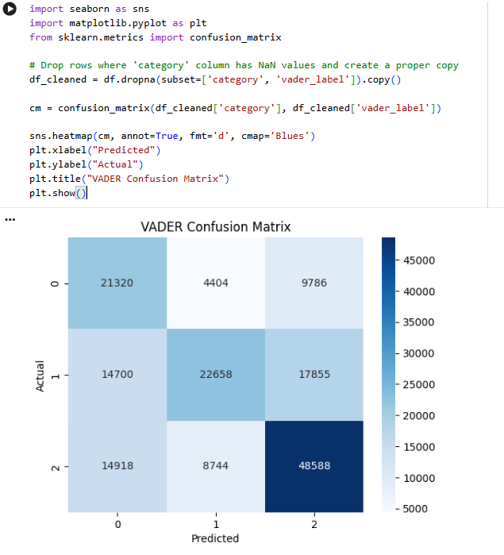
Percentage breakdown
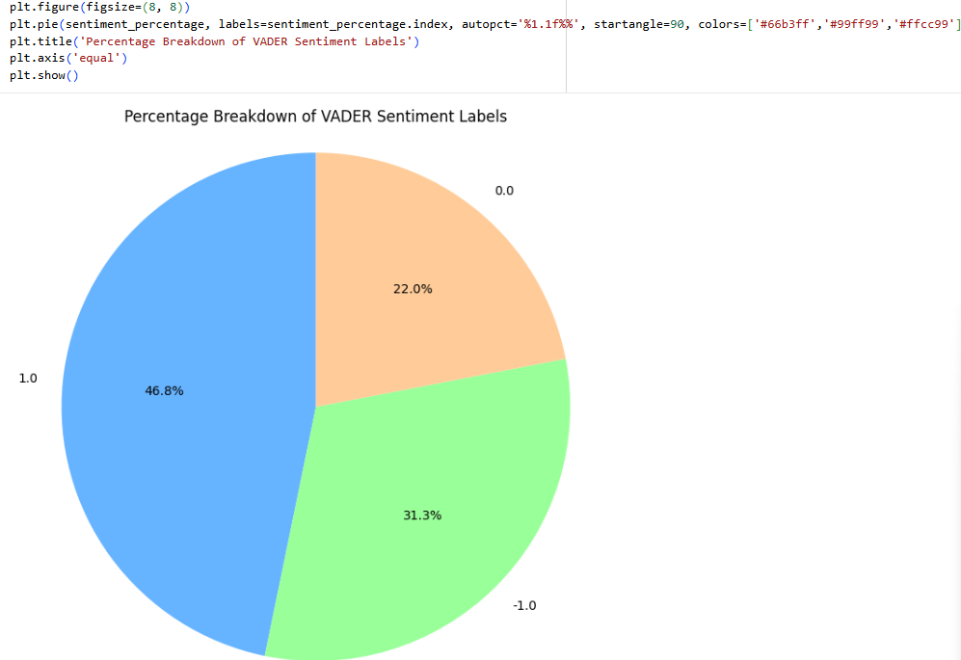
Distribution of text length

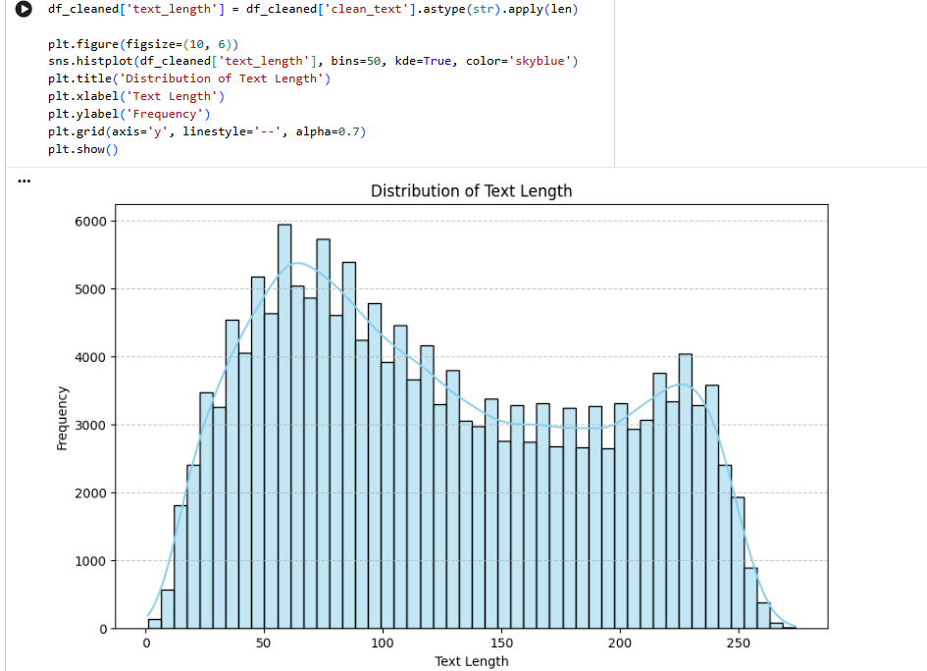

Conclusion
This project successfully analysed sentiments in X (Twitter) posts using the VADER Sentiment Analyzer. The actual dataset contained 44.33% positive, 33.88% neutral, and 21.79% negative posts, while VADER predicted 46.8% positive, 31.2% neutral, and 22.0% negative posts. The close similarity between the actual and predicted sentiment distributions indicates that VADER effectively captured the overall sentiment trend of the dataset. The confusion matrix also showed a substantial number of correctly classified posts across all sentiment categories, although some misclassification occurred between neutral and other sentiments. Overall, the results demonstrate that VADER is a reliable and efficient tool for sentiment analysis of social media text and can be effectively used for public opinion monitoring, trend analysis, and detecting negative or harmful content in online discussions.

